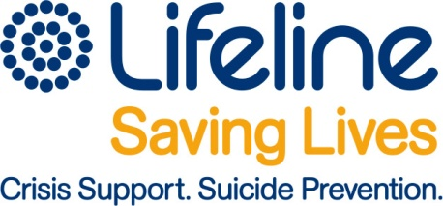
Volunteer Application Form

Personal Contact details:

Full Name
Address
Telephone:
Email
Emergency Contact Person: Name,
Mobile
Relationship

Work Situation:
Current Occupation/study
Current hours working/studying
Current skills/experience
Referees:
- Name
- Telephone

- Name
- Telephone

Course Start Month  Training Venue: | _____________  Bathurst – Orange – Dubbo
How did you hear about training | TV- Newspaper - Radio - Word of mouth - Brochure - Website - other

DECLARATIONS:
Do you have any past/present related medical conditions which may create risks for you to undertake the requirements of this position | Yes – No If Yes please explain
Do you have any past or current mental health concerns? | Yes – No If yes pls explain
As a crisis supporter you will need to complete reports on computer & be able to enter data. | Are you computer literate? Yes – No  If no, are you willing to learn Yes – No
IMPORTANT INFORMATION:

- I fully understand that any false, misleading or incomplete information stated by me in all registration documents may lead to instant dismissal if employed [voluntary or paid] by Lifeline Central West
- I certify that the information stated in registration/application forms, are true & correct in all detail
- I currently do not use/deal in or will not use/deal in illegal drugs or be involved in any criminal activity whilst involved with Lifeline.
- I will not attend training or telephone crisis support shifts under the influence of alcohol or drugs.
The personal information on this form is being collected for the purposes of recruiting & selecting volunteers to work with Lifeline Central West

By signing this form, I attest that the information supplied is true & accurate.
I understand that submitting this form does not automatically register me as a volunteer & that there is a selection process including completion of a satisfactory Police & reference checks

SIGNATURE _________________________________ DATE: ______________

